Computer Networks (CS303)

Assignment - 9

**U19CS012**

**DHCP**

* The **D**ynamic **H**ost **C**onfiguration **P**rotocol is a Network Protocol which functions at the **Application Layer** of the Internet Protocol (IP) suite.
* A Server which uses DHCP will be able to **Dynamically Assign IP** Addresses and other network configuration parameters to devices on the network; hence, Allowing communication to a Second Network.

**How Does DHCP Work?**

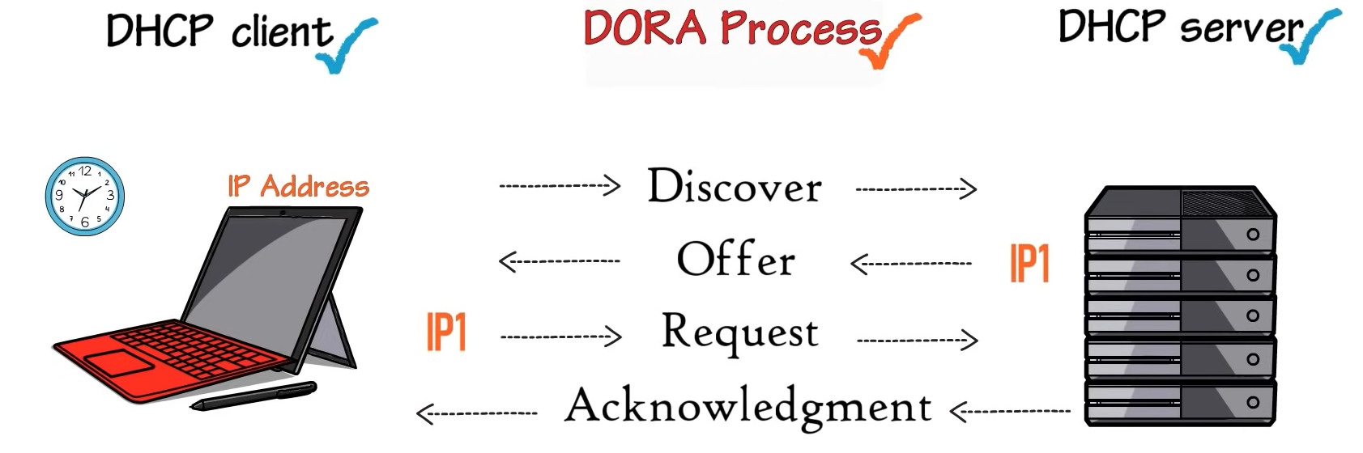

**Advantages** of using DHCP:

* **Centralized Management** of IP addresses
* **Ease** of Adding New clients to a network {Scalable}
* Reuse of IP addresses reducing the total number of IP addresses that are required
* Simple Reconfiguration of the IP address space on the DHCP server without needing to reconfigure each client

**Disadvantages** of using DHCP:

* **IP conflict** can occur

Create Manual to Create Two Network Topologies.

1.) Single Network Connected to One Router [Note: Router should work as DHCP server and Assign IP Address.]

**Step 1**: Select the End Devices [PC, Switch and Router] and connect them as shown below.

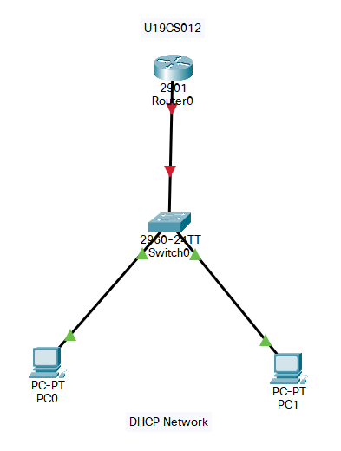

**Step 2**: Configure the Router

(A) CLI

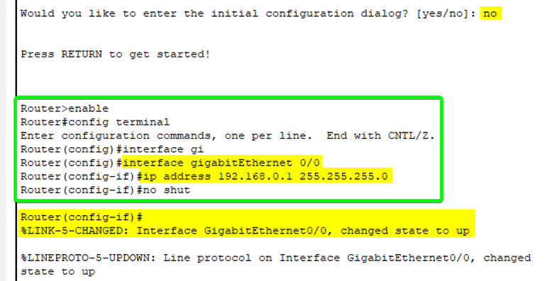

OR

(B) Without CLI

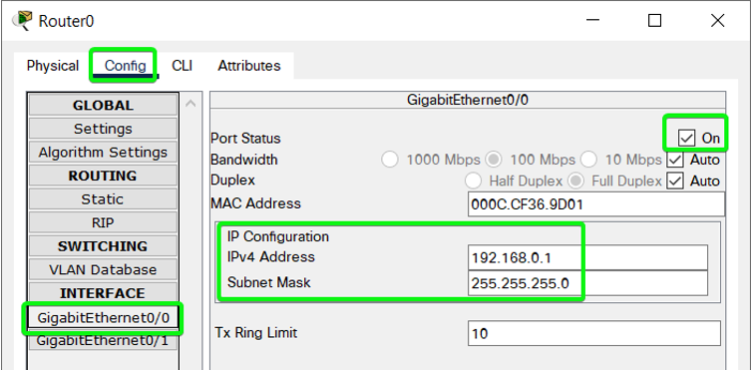

**Step 3**: Create s DHCP Pool named ‘**bhagya**’ & Give it Network Address and also set it as Default Gateway for Router.

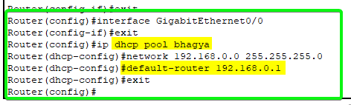

**Step 4**: Also we can exclude some IP Address [They should not be assigned to any of the Systems]



**Step 5**: Change the IP Configuration of Each of PC to DHCP.

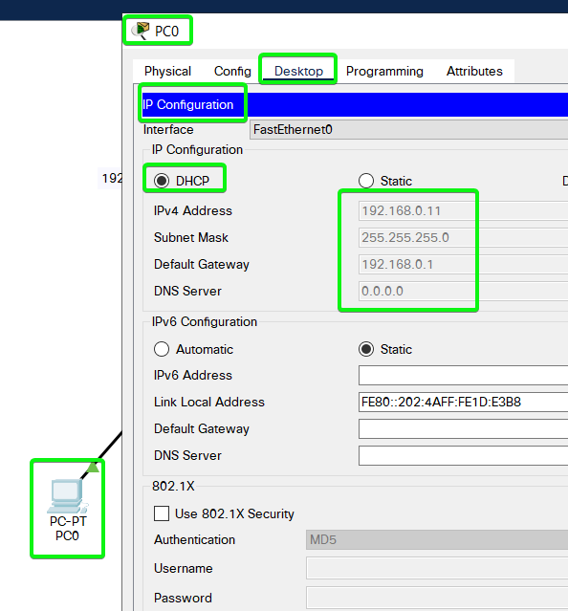

We can Notice that the IP Address of New PC is set to 192.168.0.11 {After the Excluded IP Range}

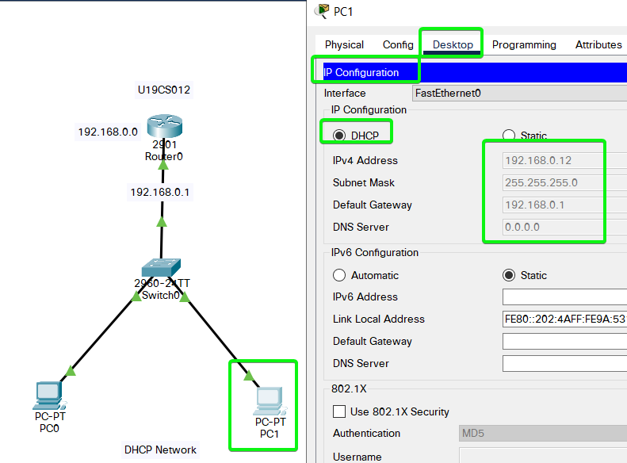

2. More than 1 Network are Connected to One Router.

[Note: Router should work as DHCP server and Assign IP Address.]

**Step 1**: Select the End Devices [PC, Switch and Router] and connect them as shown below.

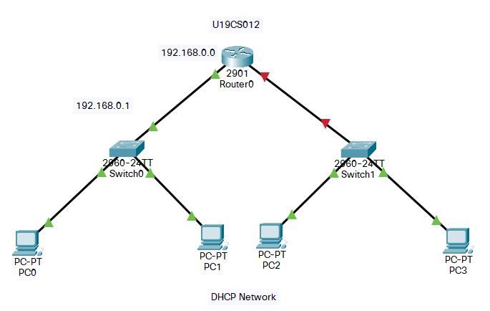

**Step 2**: Configure the Router

(A) CLI

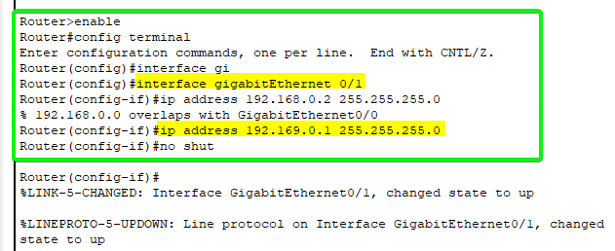

OR

(B) Without CLI

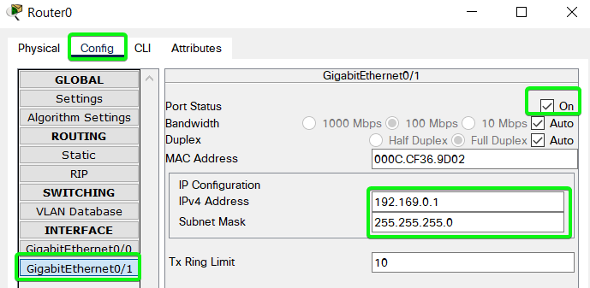

**Step 3**: Create s DHCP Pool named ‘**bhagya2**’ & Give it Network Address and also set it as Default Gateway for Router.

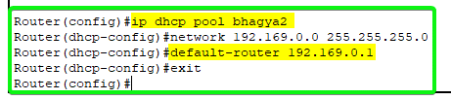

**Step 4**: Also we can exclude some IP Address [They should not be assigned to any of the Systems]

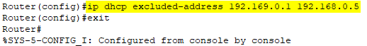

**Step 5**: Change the IP Configuration of Each of PC to DHCP.

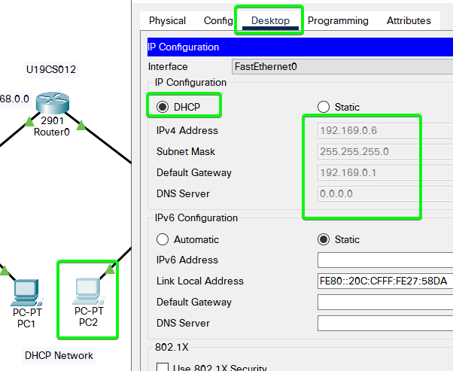

We can Notice that the IP Address of New PC is set to 192.169.0.6 {After the Excluded IP Range}

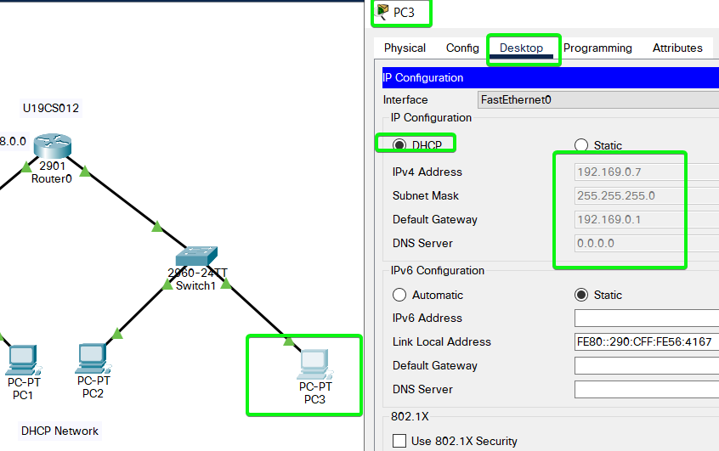

Therefore, we have successfully Implemented Two Networks and Router as DHCP server.

SUBMITTED BY:

**U19CS012**

BHAGYA VINOD RANA